Te Miro MTB Club
Saturday Kids Rides
Starts - Saturday 10th February
Finishes - Saturday 24th March
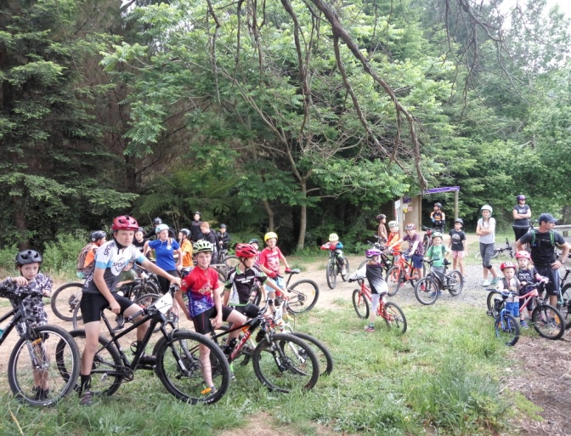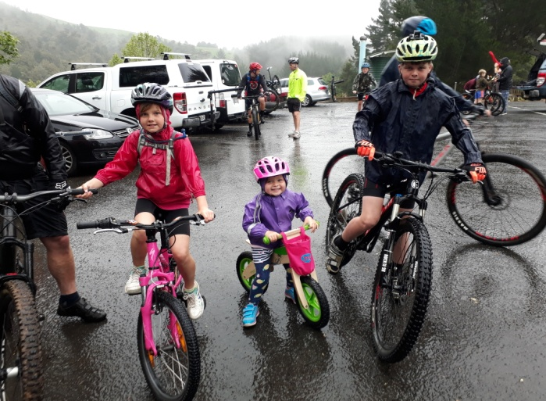
Rider briefing and tip of the week start 9:45am
Riding 10 till 12 depending on skill level
Recommended ages 8-15 - Adults welcome
Bring a drink bottle or camelback & any medication you may need
Under 8's to be accompanied by riding, walking
or running adult
Bikes must be suitable for off road use
Helmets and shoes compulsory
No cost for the rides but donations and new
members welcome
Sausage sizzle and drinks afterwards - Please bring cash
Rides are run rain, hail or shine
Phone or txt Linley for more information: 0272 363 778

